Project Proposal

On

**Hostel Management System**

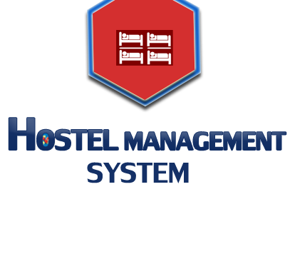

Mahammad Sameer Hussain

00174419

Computing Project

Level 5 in Computing

Softwarica College of IT and E-Commerce

Kathmandu, Nepal

09/04/2019

Submitted to: Niman Maharjan

Contents

1. INTRODUCTION 3

1.1 Justification of Project 3

1.2 Problem Statement 3

1.3 Description of Project 4

1.3.1 Features of System 4

2. Project Scope 4

2.1 Scope and Limitations 4

2.2 Aims and Objective 4

3.Development Methodology 5

3.1 Methodology used 5

3.2 Design Pattern 6

3.3 System Architecture 7

4. Work Breakdown Structure (WBS) / Scheduling 8

4.1 Work Breakdown Structure 8

4.2 Milestones 9

5. Risk Management 12

6. Configuration Management 14

7. Conclusion of the project 15

**List of figures**

Figure 1: Waterfall Model …………………………………………...5

Figure 2: Model View Controller ……………………………………………6

Figure 3: 3-Tiers Structure ………………………………………………7

Figure 4: WBS Structure ………………………………………………8

Figure 5: Days division for Tasks ………………………………………………11

Figure 6: Gantt Chart of Online Movies Booking System …………………………………………12

Figure 7: MBS on GitHub …………………………………………14

Figure 8: Tree Structure of MBS …………………………………………15

# 1. INTRODUCTION

**Project Introduction**

in this day of emerging education competition every student is mostly from the rural areas and in the country like Nepal for getting the quality Education they Have to move toward city areas and there comes the challenge finding a residence for studying. For that problem people have found hostel as an alternative solution for it. There was a day when there were limited hostels in the cities but now with the increasing students, we have problem to challenge i.e., Managing the hostel properly.  
 so with he helps of technology and general problem-solving algorithms I am here to solve the Problem Of managing the qualitative environment of Hostel. This Hostel management system is intended to solve the problem like:

* + Student not getting the seats in time
  + Students can’t see the review of any hostel or they cannot directly connect with the other hostelers.
  + Online Payments System will eliminate the Cheats in the charge of living in hostel.
  + From the review student will be able to stay away from challenging threats in the hostel Such as drug abuse, Bullying and many others
  + Student can find the hostel they can afford
  + It will generally unite the students to focus on study rather than roaming around in search of good place and Environment

## 1.1 Justification of Project

**Background of Project**

As a Student, I can surely know the issues which are we face every day in our life. As a matter of fact, I have numerous things in my psyche about Final task framework. Lastly, I have wanted to complete a framework for applying on the web lodging enlistment, charge installment technique, keep up understudy subtleties, guest subtleties, representatives’ detail and more offices with no issues for Hostel Management. I was considering last task couple of days that what to accomplish for definite venture. Finally of past week Decided to build up a framework for Hostel the board which is increasingly usable thing at the present circumstance for our Hostel Students. When I have examined with my Warden likewise, they have permitted and urged me to build up this great framework for good motivation behind understudies to spare their time and cash since they stated, for the most part this movement being as a tedious for understudies since they need to get restoration or enrollment or inn expenses installment structure, top it off, get sign from superintendent and Director. Along these lines, this system taking over two days. I have used C# .Net for programming and My SQL for manage database of Hostel management.

## 1.2 Problem Statement

Issue to sum things up in current situation every one of the subtleties identified with individuals living in lodgings are overseen by people physically and by the assistance of pen and paper. Everything is so perplexing on the grounds that it is difficult to deal with all the data of the different individuals living in an inn by the assistance of registers.

## 1.3 Description of Project

### 1.3.1 Features of System

The features of proposed system are:

* Maintain the understudies as hostellers and holding up rundown understudies independently
* Student will never again apply for their lodgings physically.
* The superintendent can see and access the understudy's information.
* To know number of things (e.g.: bed, seats) given to understudy remaining in the inn.
* Admin can send the endorsement notice to each affirmed understudy by means of email.
* Automatically embed understudy's subtleties to the hosteller's record when the designation is affirmed by the administrator and erased when get-away is accommodated or after the course end date. Students can enlist their objections.
* Admin can alter see board and every understudy can see it.
* Hostel secretary can compute lodging expense including mess charges and can alter mess menu.
* Hostellers can check the status of consistently inn charge.

# 2. Project Scope

## 2.1 Scope and Limitations

**Scope**

For the past few years the numbers of educational institutions are increasing rapidly. Thereby the number of hostels is also increasing for the accommodation of the students studying in this institution. And hence there is a lot of strain on the person who are running the hostel and software’s are not usually used in this context. This particular project deals with the problems on managing a hostel and avoids the problems which occur when carried manually

**Limitations**

Following are limitations of system as follows:

* Lack of security of data.
* Time consuming.
* Consumes large volume of paper work.
* Manual work
* Redundancy of data
* To avoid all these limitations and make the system working more

Accurately it needs to be computerized.

## 2.2 Aims and Objective

The Project is “Hostel Management System”. will be a web-based system that will be used for maintaining the records in an organized manner and to replace old paper work system. This project aims at automating the hostel management for smooth working of the hostel by automating almost all the activities. Updates and modifications will be easily achievable and all the calculations and accounting work would be accurate.

.

# 3.Development Methodology

## 3.1 Methodology used

I have used waterfall approach for this project. Waterfall model is first approach used in the software development. This model is sequential approach where one step must finish before start another step. In waterfall model each step is divided. Outcomes of one step is input for next step in waterfall model. Here steps are divided into six different phases i.e. Requirement analysis, Design, Implementation, testing, Deployment (TutorialPoint, 2018)

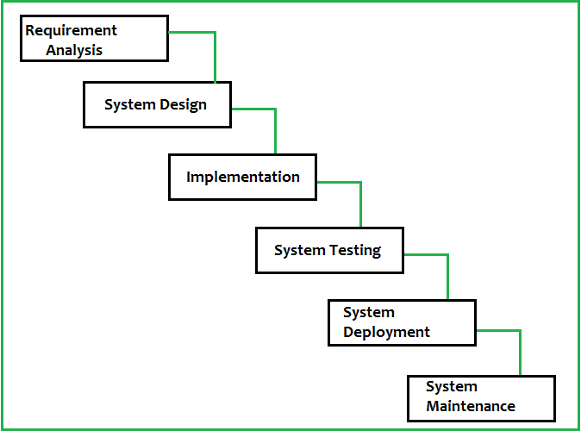

Figure : Waterfall Model

Firstly, all possible requirements are collected and document in requirement gathering phrase. From references of requirement phrase, System design is prepared. From design phrase, system is developed in small program called as unit in implementation. Each unit is tested in testing phrase which is called as unit testing. After completion of all functional and non-functional testing, system is deployed in client environment in deployment phase. After installing to client environment, system maintenance is done.

## 3.2 Design Pattern

Design Pattern is reusable solution for commonly occurring problem in software development. I am using **MVC (Model View Controller)** design pattern in this project. MVC is Model View Controller which is most used framework in software development in todays markets. It used on both desktop and web-based application.

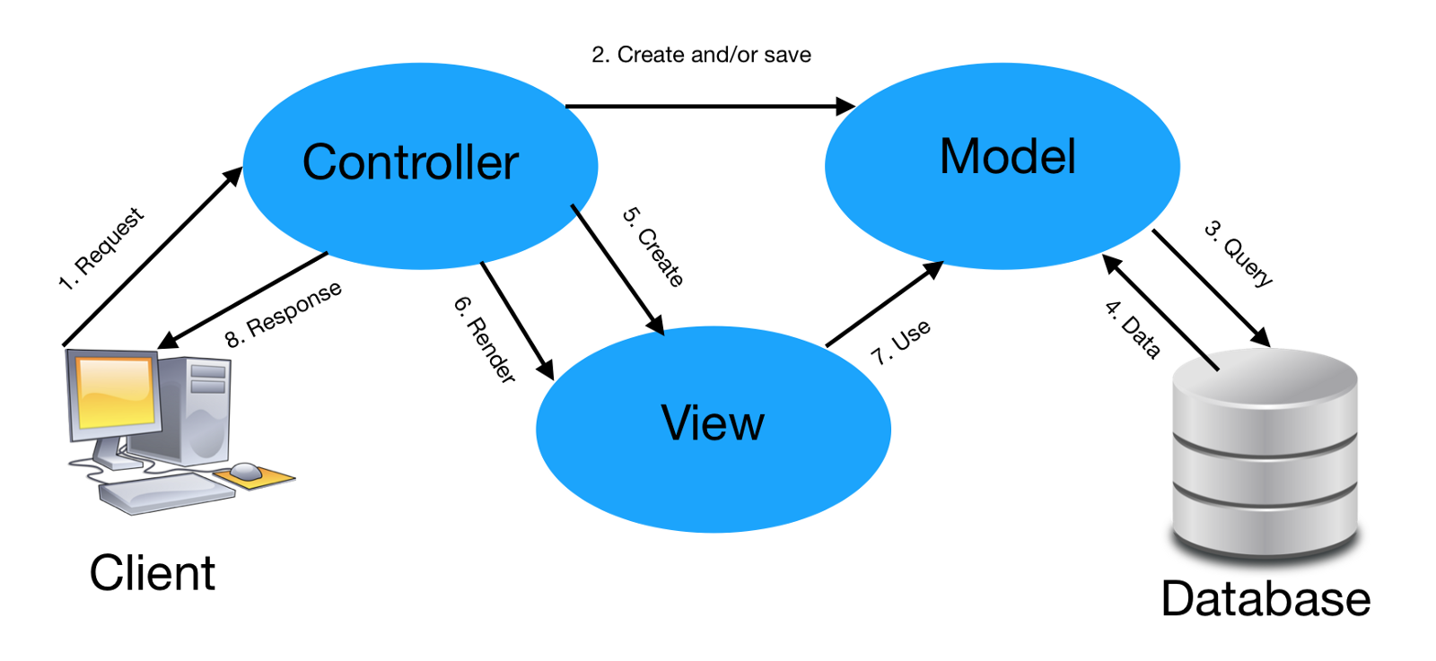

Figure : Model View Controller

**Model**

The model handles all the data related logic that user work with. This represent data that is transfer between view and controller.

**View**

The view handles all UI logic of application.

**Controller**

Controller acts as intermediary between model and view to process incoming requests and logic.

## 3.3 System Architecture

System architecture is conceptual model that defines the structure, behavior and view of system. It describes the representation of whole system. For this project, I have use 3-tier structure. (Mitre, 2016)

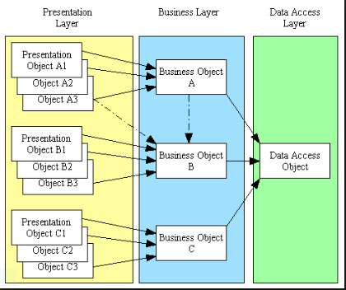

Figure 3: 3-Tiers Structure

# 4. Work Breakdown Structure (WBS) / Scheduling

## 4.1 Work Breakdown Structure

Work Breakdown Structure is process of dividing complex project into small and manageable tasks. Usually, project Manager use WBS for a project execution.

Figure 4: WBS Structure

## 4.2 Milestones

|  |  |
| --- | --- |
| **Milestones** | **Date** |
| **Project Management**  Risk Management  Project plan  Configuration Management  Submission | 3-25-2019 to 4-6-2019  3-29-2019 to 4-2-2019  3-25-19 to 3-30-19  4-2-19 to 4-5-19s  4-6-19 to 4-6-19 |
| **Analysis**  Requirement analysis  Use Case  Architecture (Initial Class Diagram)  Analysis Specification | 2019-01-04 to 2019-01-13  2019-01-14 to 2019-01-16  2019-01-17 to 2019-01-23  2019-01-24 to 2019-01-28 |
| **Design**  Structural Diagram  Behavioral Diagram  UI Design  Database Design (ER , Data Dictionary) | 2019-01-29 to 2019-02-02  2019-02-03 to 2019-02-07  2019-02-08 to 2019-02-17  2019-02-18 to 2019-02-27 |
| **Implementation**  Building Database  Coding | 2019-02-28 to 2019-03-06  2019-03-07 to 2019-03-31 |
| **Testing**  Unit Testing  Integration Testing  Blackbox Testing  Whitebox Testing | 2019-04-01 to 2019-04-03  2019-04-04 to 2019-04-06  2019-04-07 to 2019-04-08  2019-04-09 to 2019-04-10 |
| **Deployment**  User Training  Final Report | 2019-04-11 to 2019-04-15  2019-04-16 to 2019-04-20 |

**Description of Milestones**

**Project Management:**

I allocate total 14 days for this task i.e. is 4 days for Risk Management, 2days for WBS, 5 days for configuration management and 3 days for proposal.

**Analysis**

I allocate total 25 days for this task i.e. 10 days for requirement analysis, 3 days for Use case diagram, 7 days for Class Diagram, 5 days for Analysis Specification.

**Design**

I allocate total 30 days for this task i.e. 5 days for Structural model, 5 days for Behavioral model, 10 days for UI design, 10 days for database design.

**Implementation**

I allocate total 32 days for this task i.e. 7 days for database build and 25 days for coding.

**Testing**

I allocate total 10 days for this task i.e. 3 days for unit testing 3 days for integration testing, 2 days for black box testing and 2 days for white box testing.

**Deployment**

I allocate total 10 days for this task i.e. 5 days for user training and 5 days for Final Report.

**4.3 Scheduling / Gantt Chart**

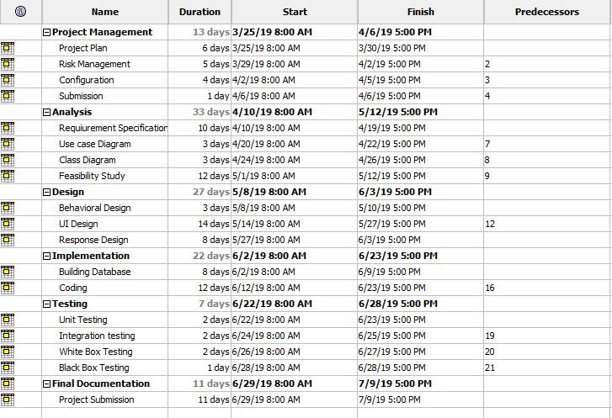 Figure : Days division for Tasks

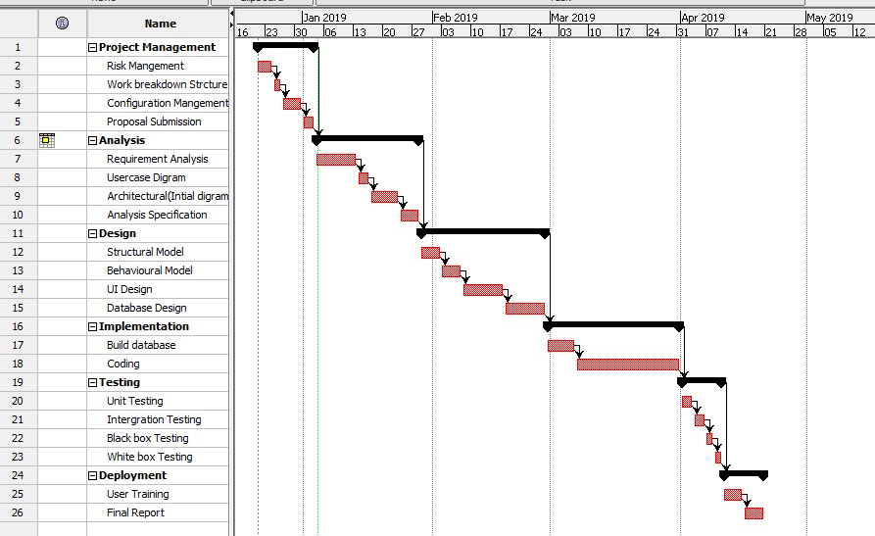

Figure 6: Gantt Chart of Online Movies Booking System

# 5. Risk Management

Risk Management is the process of identify, analyzing of risk factor in project. It should be part of planning process to figure out risk in the project and control risk for future events.

Following are the method to control risk in Project Management: (Watt, 2018)

Avoidance:

Reduction:

Sharing:

Retention:

**Impact = Likelihood * Consequence**

Risk Likelihood values are shown as follows

|  |  |
| --- | --- |
| Likelihood | Value |
| Low | 1 |
| Medium | 2 |
| High | 3 |

Risk Consequence values are shown below

|  |  |
| --- | --- |
| Consequence | Value |
| Very low | 1 |
| Low | 2 |
| Medium | 3 |
| High | 4 |
| Very High | 5 |

Risk Consequence values are shown below

|  |  |  |  |  |  |
| --- | --- | --- | --- | --- | --- |
| S. No | Risks | Likelihood | Consequences | Impact | Solution |
| 1 | Insufficient resources | 2 | 3 | 6 | All required resources for the project should be collected. |
| 2 | Hard Disk Failure | 1 | 5 | 5 | Data must back up. |
| 3 | Requirement does not meet | 2 | 5 | 10 | Proper planning should be done. |
| 4 | Server Failure | 1 | 4 | 4 | Online Backup should be done. |
| 5 | Lack of skill | 1 | 3 | 3 | Training should provide for skills employees. |
| 6 | Scheduling problem | 2 | 4 | 8 | Divide tasks in different schedule |
| 7 | Lack of cost | 2 | 4 | 8 | Cost estimation should be done properly. |

# 6. Configuration Management

The term refers to the system which track hardware, software and related information of the system. Configuration management is involving practices of processing system changes systematically with updating system while maintain the system integrity. To achieve of goal of the system, configuration management should be implemented with details polices, procedures to manage to version. Version controls are the category of software tools that helps to manage source code for the software team. (Atlassion, 2018) 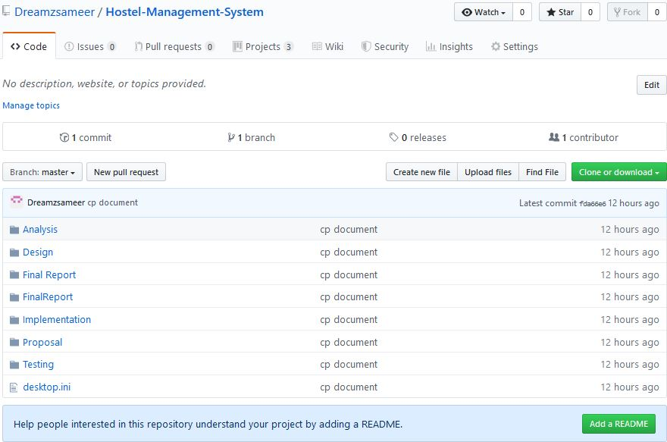

7: MBS on GitHub

# 7. Conclusion of the project

The development of the hostel management system is a user-friendly system to indents to automate the hostel from manual systems. It’s a computer-based system that will manage all the operations of the hostel. This system offers usability, stability and cost effectiveness also flexible and adaptable by any operating system. Design pattern MVC and waterfall methodology is used for the project. The only one limitation of the system is online payment system is not available.

# References

Atlassion. (2018). Retrieved from https://www.atlassian.com/git/tutorials/what-is-version-control

Mitre. (2016). Retrieved from https://www.mitre.org/publications/systems-engineering-guide/se-lifecycle-building-blocks/system-architecture

TutorialPoint. (2018). Retrieved from https://www.tutorialspoint.com/sdlc/sdlc_waterfall_model.htm

Watt, b. a. (2018). Retrieved from https://opentextbc.ca/projectmanagement/chapter/chapter-16-risk-management-planning-project-management/